Hospital Management system

22SDCS01A

2200031864 - V. Madhavi 2200031642 – Ch. Pravallika 2200031355 – L. Harshitha

Abstract:The hospital management system aims to streamline various administrative and operational processes within a healthcare facility, enhancing efficiency and improving patient care. This project addresses the challenges faced by both healthcare providers and administrators in managing hospital operations effectively. By developing a comprehensive system, healthcare providers can manage patient records, appointments, and resource allocation efficiently, while administrators can oversee overall operations and resource utilization. This abstract provides an overview of the objectives, intended solution, and implementation modules of the project.Introduction:Healthcare institutions encounter numerous challenges in managing hospital operations, including patient record management, appointment scheduling, resource allocation, and staff coordination. These challenges not only affect the quality of patient care but also impact the efficiency and effectiveness of hospital management. To address these issues, we propose the development of a hospital management system. This system aims to provide a centralized platform for managing various aspects of hospital operations, including patient information, appointments, inventory, and staff scheduling.Objective:The primary objective of this project is to design and implement a hospital management system that streamlines administrative and operational processes, leading to improved patient care and enhanced efficiency. Specific objectives include:Developing a user-friendly interface for healthcare providers to manage patient records, appointments, and medical histories.Implementing modules for appointment scheduling, resource allocation, and inventory management to optimize hospital operations.Providing administrators with tools to monitor overall hospital performance, including patient flow, resource utilization, and staff productivity.Integrating features such as electronic health records (EHR), billing and invoicing, and reporting functionalities to ensure comprehensive management of hospital operations.Enhancing system scalability and interoperability to accommodate the evolving needs of healthcare institutions and integration with existing healthcare IT infrastructure.Intended Solution:The intended solution is to develop a robust, web-based hospital management system that offers a wide range of features to support efficient hospital operations. The system will feature a user-friendly interface for healthcare providers to access patient information, schedule appointments, and manage medical records. Administrators will have access to dashboards and reporting tools to monitor key performance indicators, such as patient occupancy rates, resource utilization, and revenue generation.Implementation Modules:The implementation of the hospital management system will consist of several modules, including:Patient Management: Module for managing patient demographics, medical histories, appointments, and treatment plans.Appointment Scheduling: Module for scheduling patient appointments, managing physician schedules, and sending appointment reminders.Inventory Management: Module for tracking medical supplies, equipment, and pharmaceuticals, ensuring efficient resource utilization and procurement.Staff Management: Module for managing staff schedules, roles, and responsibilities, optimizing workforce allocation and productivity.Billing and Invoicing: Module for generating invoices, processing payments, and managing insurance claims, ensuring accurate financial transactions and revenue management.Reporting and Analytics: Module for generating reports on hospital performance, including patient demographics, resource utilization, revenue generation, and clinical outcomes.Limitations:While the hospital management system aims to improve the efficiency and effectiveness of hospital operations, it may have certain limitations, including:Integration Challenges: Integration with existing hospital information systems and electronic health record (EHR) platforms may pose technical challenges and require additional resources.Training Requirements: Healthcare providers and administrative staff may require training to effectively use the system, especially if they are not familiar with healthcare IT systems or electronic record-keeping.Data Security Concerns: The system must adhere to strict data privacy regulations and security standards to ensure the confidentiality and integrity of patient information.Resource Constraints: Limited financial resources and technical expertise may impact the implementation and maintenance of the hospital management system, potentially affecting its effectiveness and scalability.Overall, the hospital management system offers significant potential to enhance the quality of patient care, improve operational efficiency, and optimize resource utilization within healthcare institutions. By addressing the challenges associated with hospital management, this system can contribute to the delivery of high-quality healthcare services and better patient outcomes.

Insights gathered

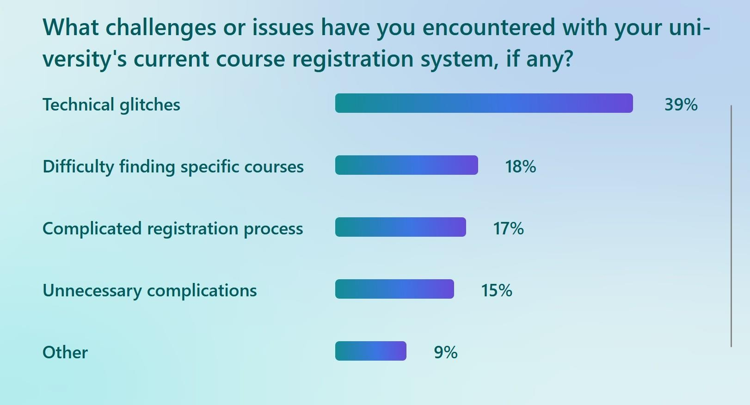

Academic Report

5



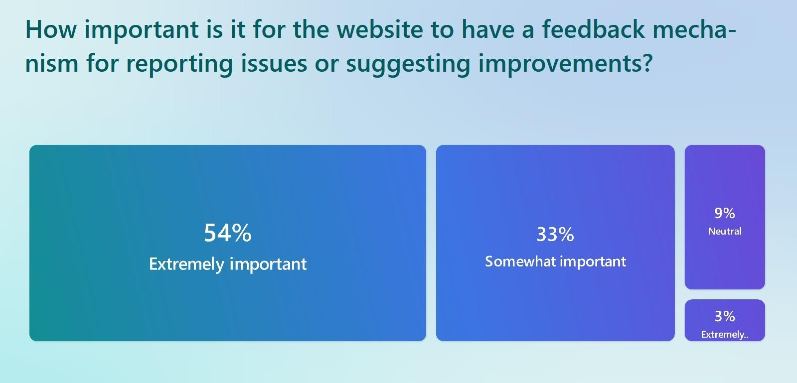

Academic Report

Fieldwork





Final output:-

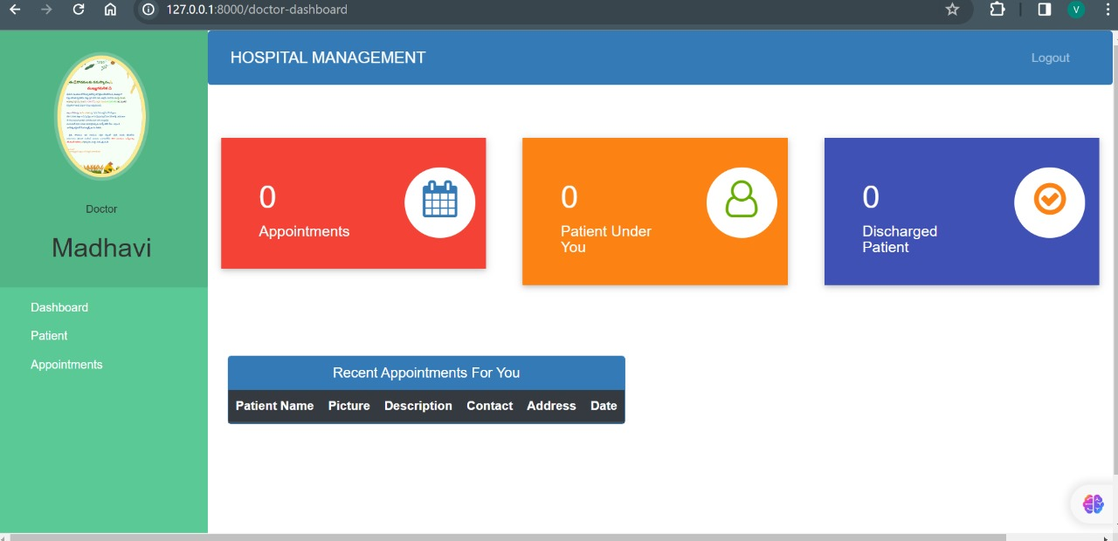

Conclusion:

In conclusion, the academic student course registration system offers a comprehensive solution to the challenges faced by academic institutions in managing course registration. By providing students with an intuitive platform to browse and register for courses and offering administrators tools to efficiently manage course offerings and enrollment, the system aims to improve the overall academic experience for students and reduce administrative burden. Despite potential limitations, the system has

the potential to enhance the efficiency and effectiveness of course registration processes in academic institutions.